Design Rational

This is for the simple tile map game made by Devlan McKenzie, 1876492

# Introduction

This paper will discuss the reasons behind the creation of the tile map game and cover some of the methods used in its creation. This will hopefully provide some insight as to why I made the content the way I did and will use the familiar rationale format to assist in this process.

# The Question

This question will not be as in depth and defined as the other rationale questions prior to the making of this game, this is simply because we were given more freedom and as such I wanted to try make something I am unfamiliar with and could be challenged by.

This mind set lead to the want to pick up a new skill and implement it in a relatively simple game; the inspiration for this game was Stardew Valley which made use of tile maps and did so effectively, as such I wanted to test how hard it would be to make and use tile maps within the context of Unity and then develop a game around said tile maps.

The question thus became something a kin to this, can I make a basic pixel art tile set and use it to create an environment, if so can I use the environment to create a simple 2D game. What are the challenges encountered in this task and what methods are suitable for a beginner to overcome these challenges?

# The Process

The process used to investigate the question proposed above was simple. The task was broken up into smaller parts to make it more manageable, this was namely the creation of the tile set , the implementation of the tile set and then the creation of a simple game in which the player had a reason to explore the world, a method to do so and a goal. This will now be discussed in detail firstly the creation of a tile set , as a complete beginner to pixel art and tile sets the need to research the topic was clear. This research lead to the discovery of a few things namely the use of 3 shades of a colour and then light and dark shadows will allow the creation of simple pixel art, and the optimal size for a beginner was something smaller like 32 pixels by 32 pixels. This allowed me to start creating the tile set.

The method for creating the tiles was to create a new project in Photoshop and size it to be 32 by 32 pixels; this was done in Photoshop because it allows for the creation of smart objects. These are basically images that will update if any of their copies were updated, this meant I could rotate and place them to create the basic shapes need to create an environment and then edit them to make them flow into one another nicely.

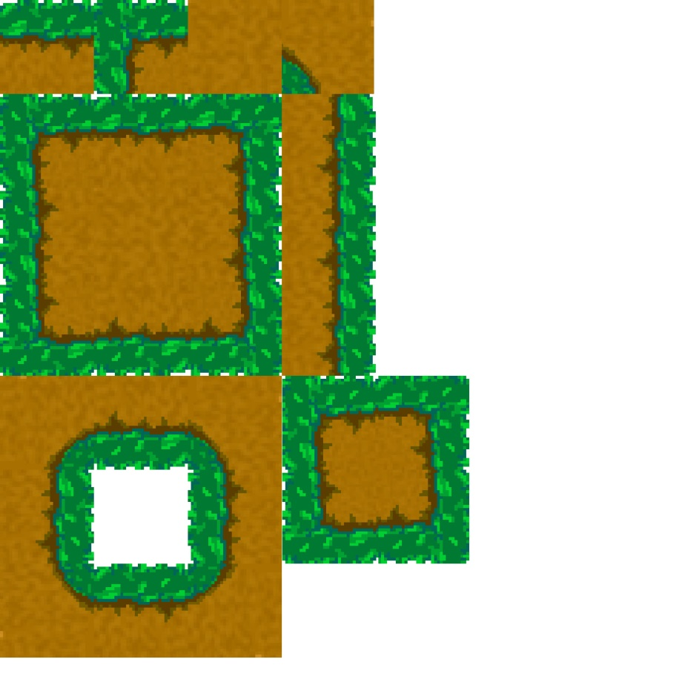

As you can see I am clearly a beginner however this image will allow me to reference the colours and explains what I mentioned above. The four essential tiles are those at the top going left to right and are the ones used to make up the rest of the tile set. If you are struggling to make these tiles, there are many tutorials found online and can be used as step by step guides. I later made a water tile using a simple method similar to the ground tile which I shall discuss below.

The use of the 3 shades can be seen above it is important to note that one may use more than 3 shades per block of 32 by 32 pixels for instance the grass block. The shades refer more to 1 part of the thing you are trying to make and in this case it is grass and dirt so 2 x 3 shades. At first this threw me off as a beginner I didn’t know these things and found it difficult to work with even 3 shades.

This lead to some more research and I came across a simple trick to make decent looking tile backgrounds, the trick is simply to create a background colour then duplicate the layer and then apply some noise to the layer. I found that for 32 by 32 pixels a range of noise from 1 to 3 percent works well and after that you simply have to touch up the edges so that they flow well.

The tile set above was made using these simple methods and while they look terrible up close are actually decent from a further distance.

The next challenge was the creation of a tile map in Unity for this I did some more research and found that you simply had to place all your images on a single image and then drag and drop it into Unity. After this you could set the sprite mode to single and change the pixels per unit to the size u made so in this case 32 pixels. The quality could then be changed by the other settings and I found that using the point filter mode or no filter and setting the compression to none produced the best results and the research agreed with this.

A surprising challenge for something so simple I kept running into size issues with the 32 pixels and it seemed that somehow the images where now larger than 32 pixels, to solve this I imported them in individually and gave each the settings above which while tedious got the job done.

Next the creation of a Unity tile map for this you can use the built in tile map system and use the Tile palette system to paint your environment. This proved to be an easy task and the environment was made in no time however there were these weird lines and gaps everywhere. This task was only easy because we set the correct pixels as mentioned above if they are too big it’s an issue and they overlap and create havoc. So having the correct size that matches the grid is essential, I do believe other sizes will work and allow for more detail but as a beginner this will be more suitable.

The solution for this problem was the disabling of anti-aliasing and this solved the problem if it is still there in some places its and issue with the way you drew the tiles and you will have to go and fix them and repeat the process above.

At this point I had a very brown environment and while I had made what I set out to make it felt bland, at this point I made a water tile and used the noise trick I mentioned earlier and just added some highlights for that 3 shade. I then made an island environment and decided to start making the game.

I imported an asset pack from the asset store that was free and called Tasty_Characters - Forest Pack, I did this so that I could use 2 of their sprites 1 is for my player and another is for the enemies. The reason I did this was because my question was more centred on the creation and use of a tile set and not a character, thus I thought it okay to do so and plan to make my own characters later on.

The game was implemented using these characters mentioned above and made use of a simple movement system with no animation. At this point the player could explore the world but also could walk off the environment which posed an issue. The solution was to make another tile map as they act as layers and add colliders to this one; this solved the problem and prevented the player from walking outside the environment. After doing a bit more research I discovered that each block had its own collider which was poorly optimised and found a solution in the use of a composite collider which made all the colliders that where touching into a single collider.

I also noted that I had painted the walls twice on my tile map which was a waste as one of the set of walls will never be seen and thus removed them to further optimise, this meant that the colliders had the only set of walls and allowed for a better workflow. My advice to any beginner is to paint the base like water and land on a tile map and call it base and then paint things with colliders like cliffs and grass hedges on another tile map and in this way your work is organised and manageable.

At this point I have answered 2 of the 3 things under game in my question which are a reason to explore the world, a method to do so and the only thing left was a goal. The interesting thing about explore the world was that as soon as you had the means to explore the world, you already had a reason which was simply because it was there and that you could explore it. This however does not make for a game and thus needed the goal to incorporate some game play. This lead to the creation of an enemy swarm mechanic and these chased the player using super basic code. The player had a score and could shoot the enemies using a left mouse click which produced a fireball. The player died on contact and was show a message press R to restart.

This concluded the game and the question and allowed for me to start the reflection process.

# Reflection

In conclusion I have picked up a new skill and can now make use of tile maps and create basic tile sets. These allowed me to create an environment and allowed for the creation of a basic 2D game. There are many challenges that have been discussed above and a few tricks to help you out as you learn more. Methods to help you out can be found in abundance online and on YouTube. If you are a beginner like me then stick to a smaller pixel size and make it square, use this size throughout your tile set creation and use a maximum of 3 shades per colour on a single part of an object. The last bit of advice is to reference what others have done and see how they did it, keep practicing and you will become better and just work through it as I and many others have and you will come out okay.